HEALTHCARE ANALYSIS PROJECT REPORT
1. Introduction
Healthcare Analysis is a data analytics project used to understand patient information in a simple way. The project analyzes patient details such as disease, treatment status, city, gender, BMI, blood pressure, heart rate and oxygen level. Excel, SQL and Power BI are used to prepare, analyze and visualize the
data.
2. Problem Statement
Healthcare data contains many patient records and can be difficult to understand in raw form. The main purpose of this project is to organize the data, find useful information and present the results through an easy-to-understand dashboard.
3. Objectives
• Understand the patient dataset.
• Clean and organize data using Excel.
• Use SQL to filter, group and summarize patient information.
• Create KPIs and charts in Power BI.
• Analyze diseases and treatment status.
• Analyze patients by city and gender.
• Study BMI, heart rate, oxygen level and blood pressure.
• Create an interactive healthcare dashboard.
4. Tools Used
Tool Purpose
Excel Data cleaning, formatting, checking missing values and basic analysis.
SQL Querying, filtering, grouping and calculating patient information.
Power BI Creating KPIs, charts, filters and the final interactive dashboard.
5. Dataset Description
The dataset contains 501 patient records and 15 columns. Important fields include Patient ID, Gender, Age, City/State, Disease, Date, BMI, Blood Pressure, Heart Rate, Oxygen Level, Smoking and Staus.
6. Project Process
Step 1 - Excel: Open the raw patient data, check the columns, remove incorrect or duplicate records, check blank values and make the data ready for analysis.
Step 2 - SQL: Store/query the patient data and use SQL commands such as SELECT, WHERE, GROUP BY,COUNT and AVG .
Step 3 - Power BI: Connect the prepared data, create relationships if required, create measures/KPIs and build charts.
Step 4 - Dashboard: Add slicers for Date, City_State and Patients_ID and present the important results in one dashboard.
7. Key Analysis
Analysis Value
Total Patients 501
Critical Patients 183
Under Treatment 159
Recovered 159
Average BMI 26.87
Average Heart Rate 96.49
Average Oxygen Level 82.58
8. Disease Analysis
• Asthma: 170 patients
• Hypertension: 167 patients
• Diabetes: 164 patients
The dashboard compares the major diseases and makes it easy to see which disease has more patient
records.
9. Treatment Status Analysis
The treatment chart shows 183 Critical, 159 Under Treatment and 159 Recovered records. This helps
understand the overall treatment condition of patients.
10. City and Gender Analysis
Top five cities by patient count:
• Kolkata, West Bengal: 49 patients
• Hyderabad, Telangana: 48 patients
• Bengaluru, Karnataka: 48 patients
• Ahmedabad, Gujarat: 45 patients
• Surat, Gujarat: 43 patients
The dataset contains 251 female and 250 male records. The dashboard can be filtered to compare patient groups.
11. Dashboard Explanation
The Power BI dashboard contains filters for Date, City_State and Patients_ID. The KPI cards display Total Patients, Critical Patients, Under Treatment, Average Heart Rate, Average BMI and Average Oxygen. Charts display disease distribution, treatment status, top cities, disease by gender and blood pressure.
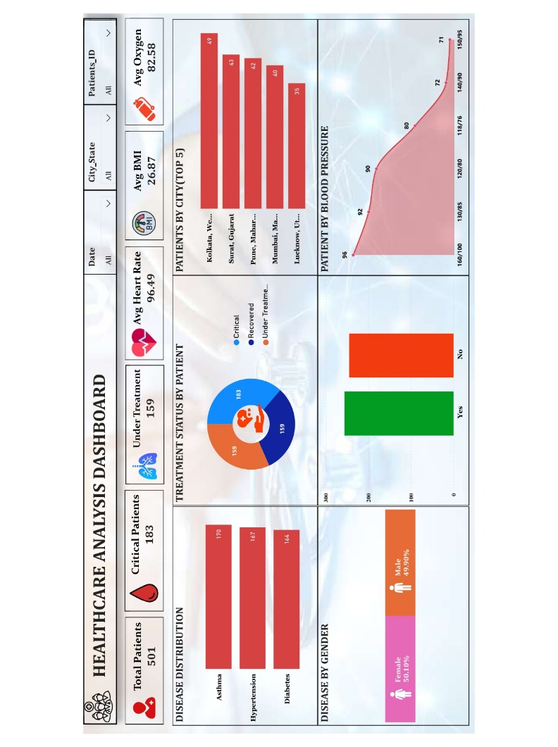
12. SQL Analysis
SQL is used to answer questions from the healthcare dataset. Examples include finding total patients,
counting patients by disease, finding patients by treatment status, finding the top cities and calculating
average BMI, heart rate and oxygen level. SQL makes it easy to filter and summarize large datasets.
13. Excel Analysis
Excel is used as the first stage of the project. The data can be checked for duplicate records, blank values,incorrect formats and inconsistent entries. Excel filters, sorting, tables and basic formulas can also be used to check the data before importing it into Power BI.
14. Power BI Analysis
Power BI is used to create the final dashboard. It converts the analyzed data into KPI cards, bar charts, donut charts, line/area charts & slicers. Users can select a date, city, patient ID & view filtered result.
15. Key Findings
• The dataset contains 501 patient records.
• Asthma has 170 records, followed by Hypertension and Diabetes.
• There are 183 critical patient records.
• The average BMI is 26.87.
• The average heart rate is 96.49.
• The average oxygen level is 82.58.
• The dashboard allows users to interact with the data using slicers.
16. Conclusion
This project shows how Excel, SQL and Power BI can be used together for a simple data analytics workflow. Excel helps prepare the data, SQL helps analyze the data, and Power BI presents the results visually. The final dashboard provides a clear view of patient diseases, treatment status, location, gender and health measurements.
17. Future Scope
• Add hospital and doctor analysis.
• Add monthly and yearly patient trends.
• Add more healthcare KPIs.
• Connect Power BI directly to a SQL database.
• Add automatic data refresh

